***2019***

***Chardonnay***

This very special Chardonnay was made in the style of a traditional Burgundian Chablis. It shows intense citrus and soft fruit layered with brioche, honey and walnut carried by a distinct minerality and crisp acidity with a lingering citrus finish.

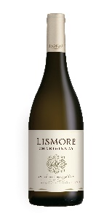

***Winemakers' Notes***

The grapes were picked at optimal ripeness and whole bunch pressed, slowly extracting the juice at a rate of 600ltrs per ton. The juice was cold settled for 48 hours and was racked into 225, 300 and 500 litre older burgundian barrels for fermentation and 11 months of maturation. 5% new French oak was used in this vintage.

***Wine Making Aesthetic***

Balance is the key to this wine.

The oaking represents a viewpoint that the fruit/acid/pH must drive a wine's flavour and not the over-emphasis on highly extracted buttery notes derived from new barrels and 100% Malolactic conversion. That being said the barrel aging gives this wine its luxurious texture. Having only undergone partial MLF (20%), the wine retains its original fruitiness and fresh acidity. These elements combined allow for years of storage and maturation.

***Wine of origin Western Cape***

***Alcohol: 13.5%******pH: 3.37 Total Acidity: 6.38 g/l RS: 1.85 g/l***